hdfs dfs -ls /
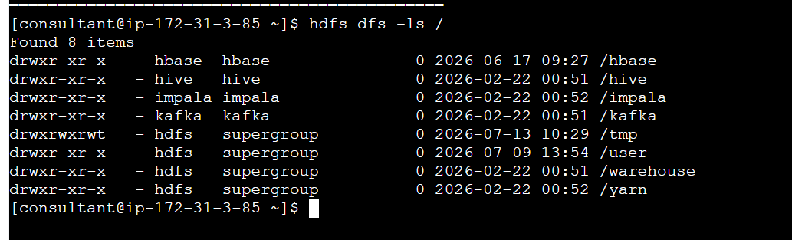
Created a employee.csv file on the server
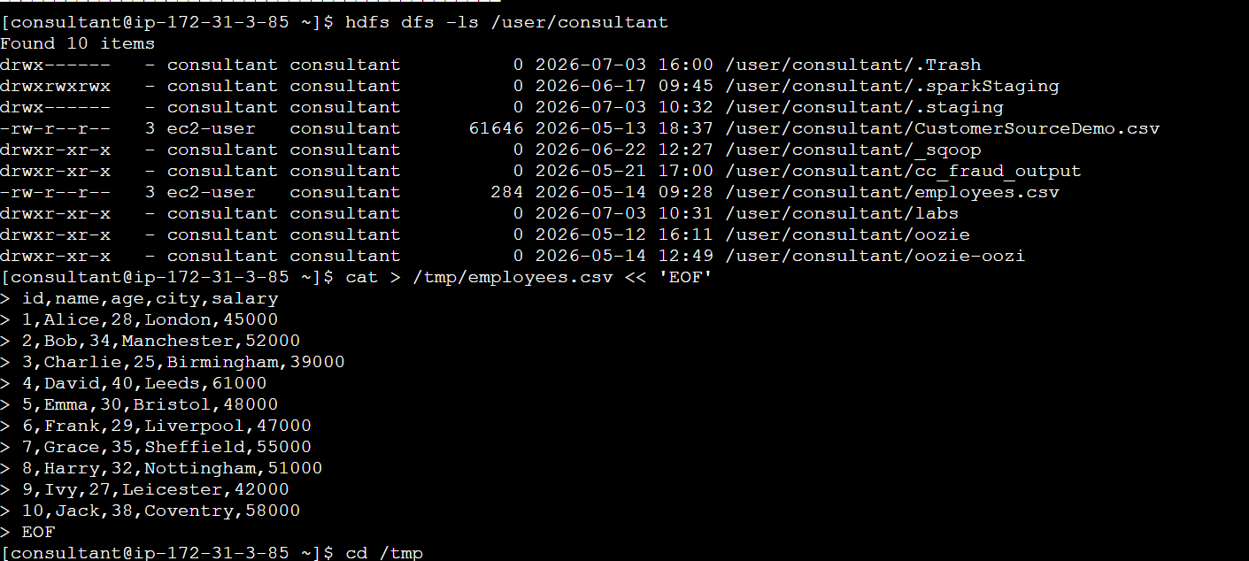

Adding the file to HDFS

File created with 284 mb size
owner/user can read&write
Others can read
Checking if the file is there in hdfs
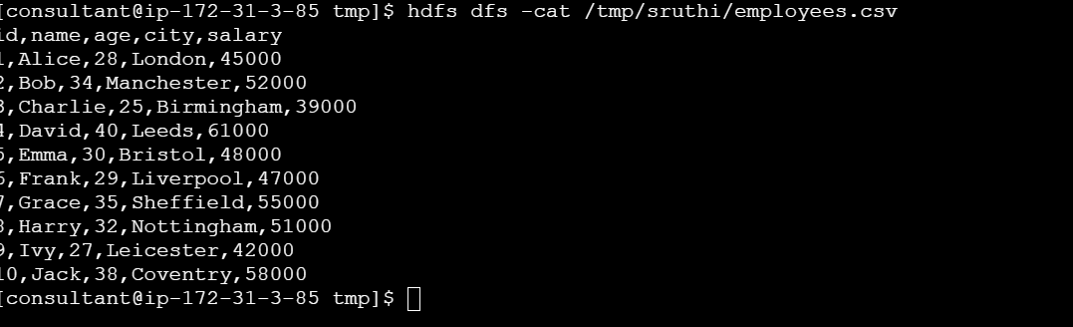
Checking file size

Setting replication to two
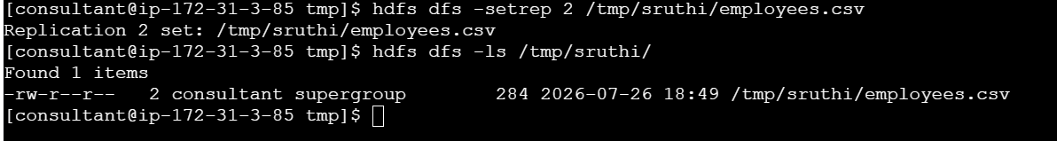

DAY 2

MapReduce Approach: City-wise Employee Count
The employees.csv file contains employee records, with the city field located at index 3 (the 4th column) in each row.
The Mapper reads the file line by line, skips the header row, extracts the city field from each record, and emits it as a key-value pair in the form city, 1.
During the Shuffle and Sort phase, Hadoop automatically groups all key-value pairs by city, ensuring that all occurrences of the same city are brought together before reaching the Reducer.
The Reducer then iterates through these grouped pairs, maintaining a running count for each city. As it processes consecutive pairs, it accumulates the count while the city matches, and once a new city is encountered, it outputs the total for the previous city and resets the counter. This produces the final result: a count of employees per city.
Mapper
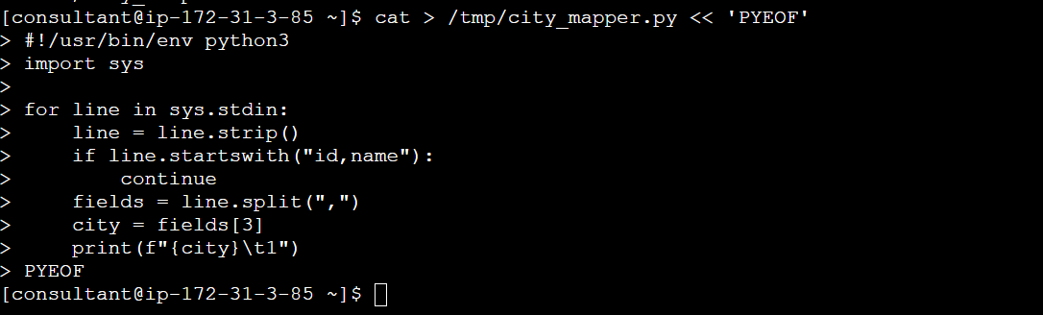

Reducer
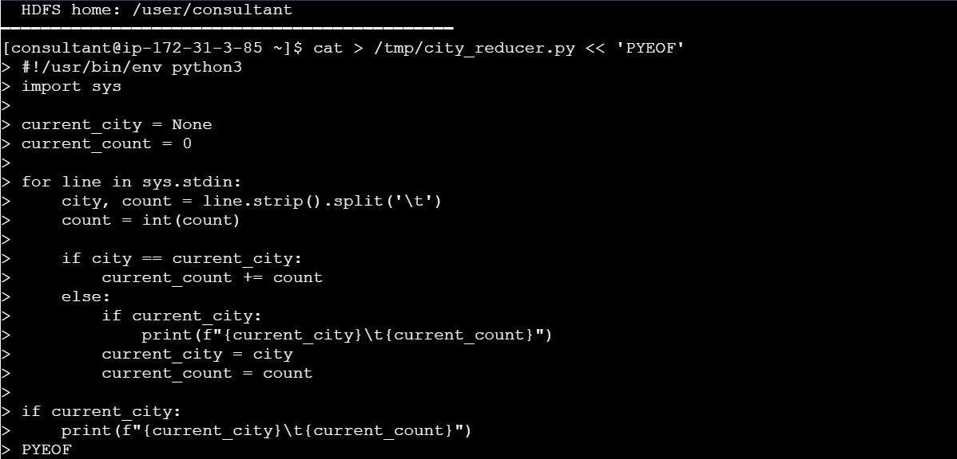

giving mapper and reducer execute permission to the user

Run the job
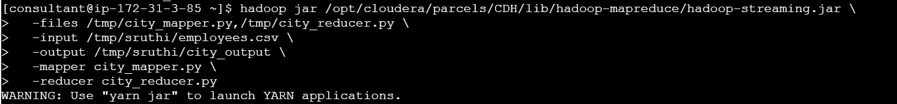

Checking if the output is present
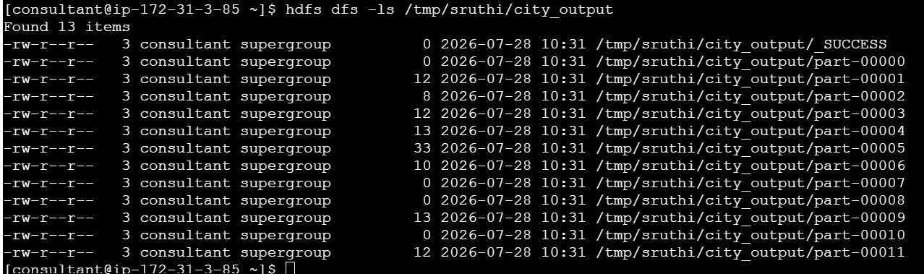
Display output in a merged text file 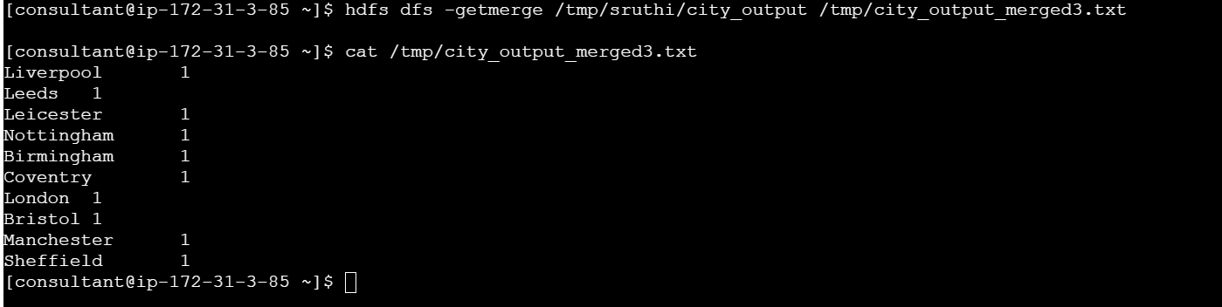

DAY 3
Permissions

- Hdfs dfsadmin report
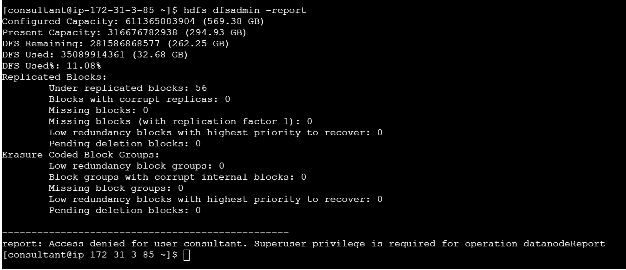

2. Run hdfs fsck /tmp/itc_runbook -files -blocks — confirm all blocks are HEALTHY
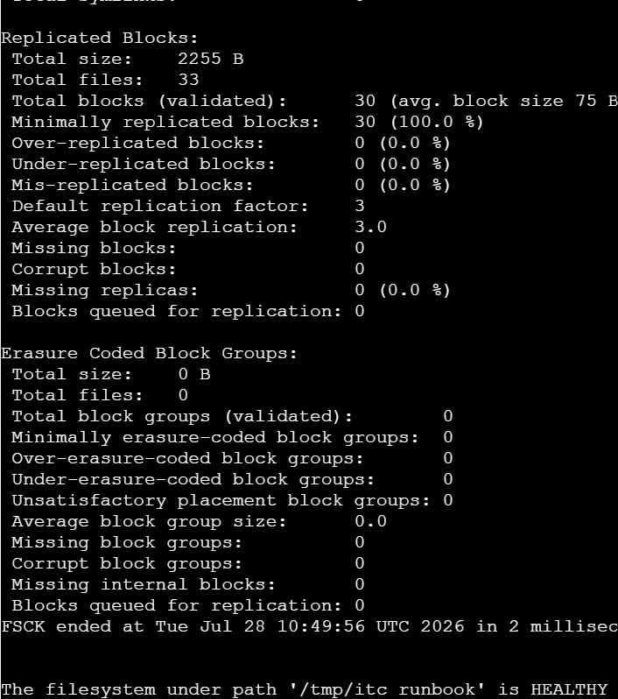
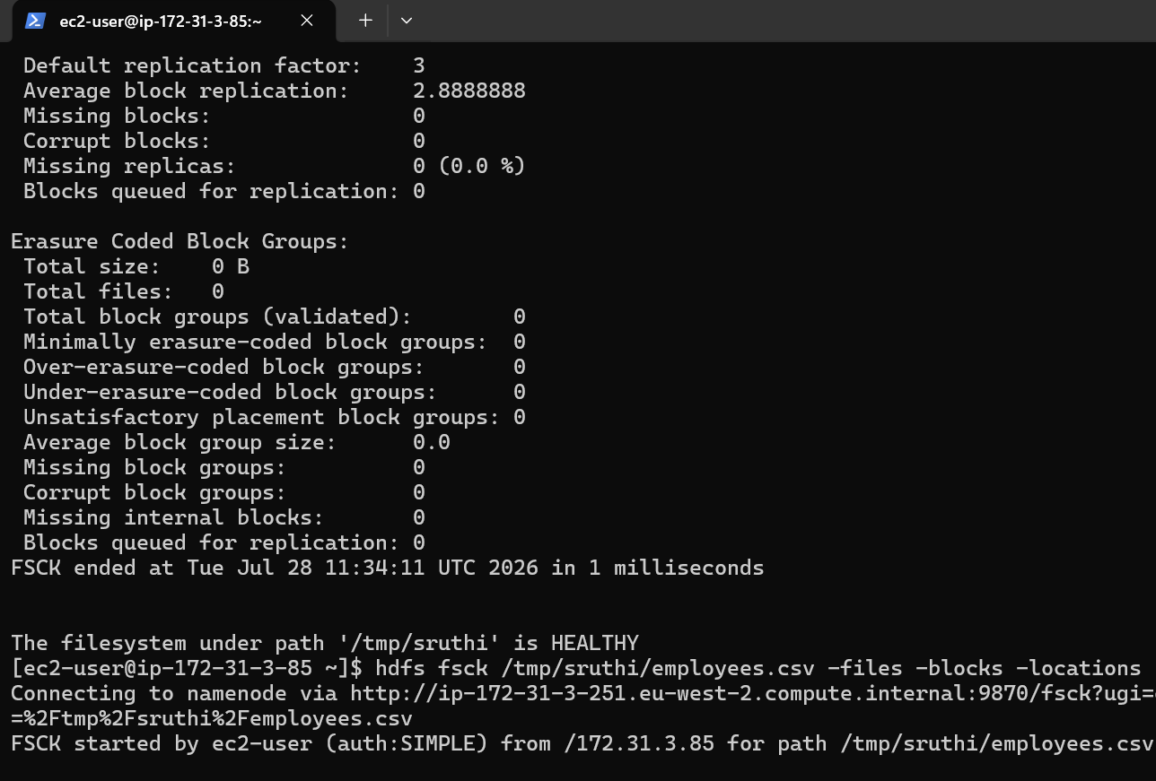
3. Enable snapshots on /tmp/<yourname>, create a snapshot called day3_checkpoint
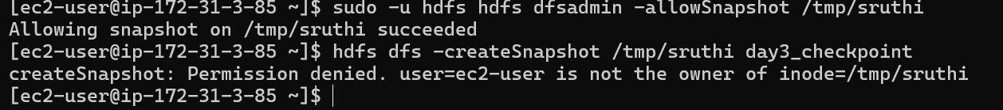
4. Delete employees.csv from your directory, then restore it from the snapshot

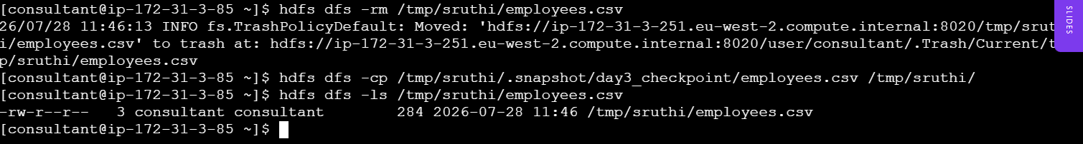5. Use distcp to copy /tmp/<yourname> to /tmp/<yourname>_backup

6

7. cleanup

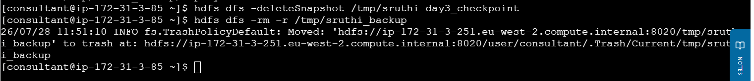

Day 4
- Node list
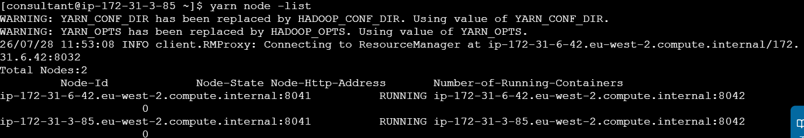

Day 5
1. Create table under your name on itc_runbook

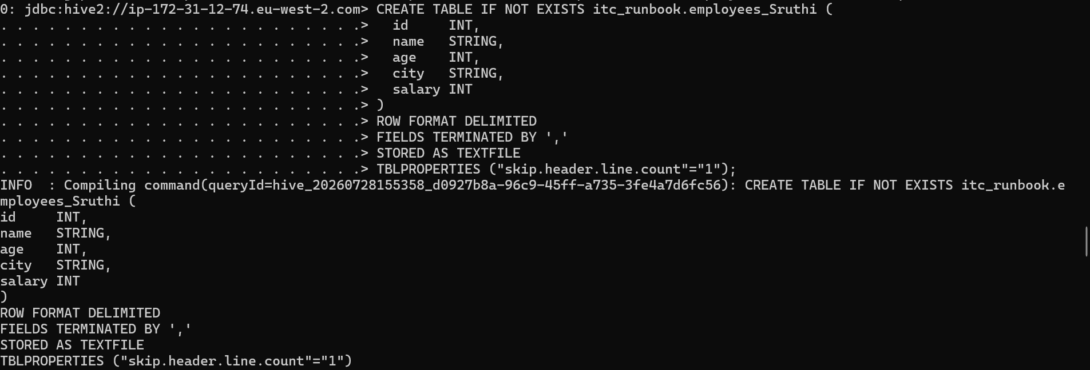

- Load data
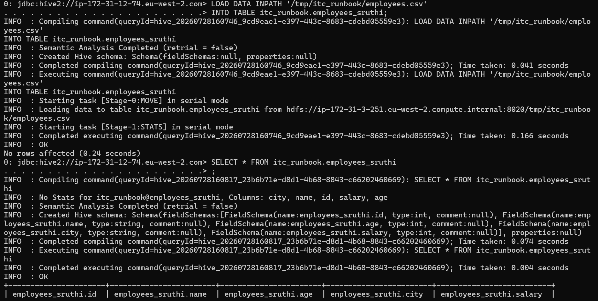
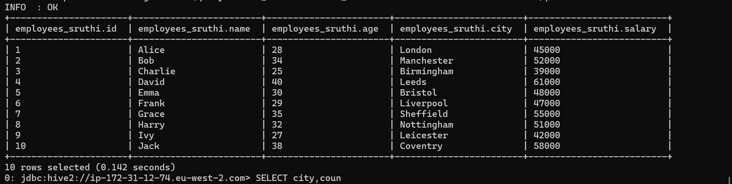
- Employees with age > 30
SELECT * FROM itc_runbook.employees_sruthi WHERE employees_sruthi.age>30
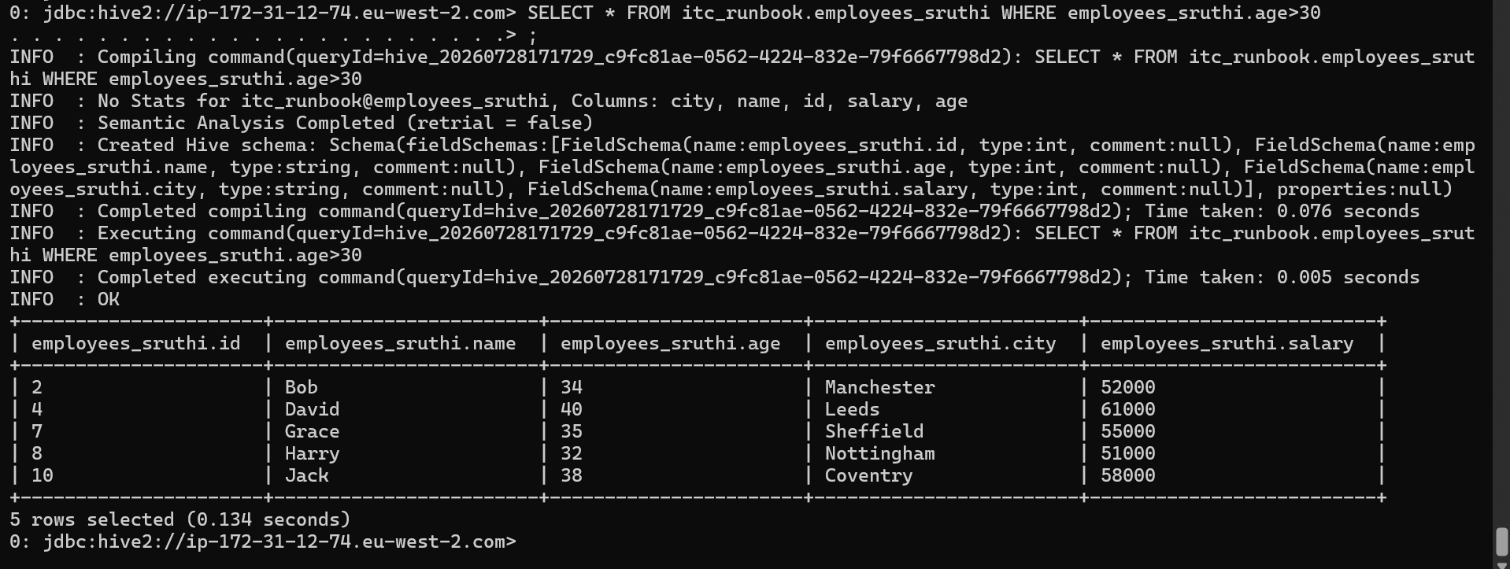
- Employee with highest salary in each city

SELECT city, name, salary
FROM (
SELECT city, name, salary,
ROW_NUMBER() OVER (PARTITION BY city ORDER BY salary DESC) AS rn
FROM employees_sruthi
) ranked
WHERE rn = 1;

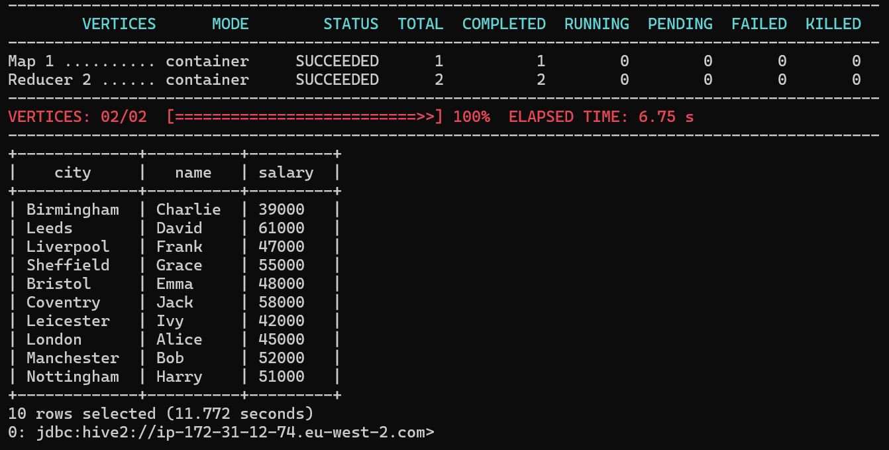

Day 6

- CREATE TABLE itc_runbook.sruthi_orders (
order_id INT,
product STRING,
amount DOUBLE,
region STRING
);

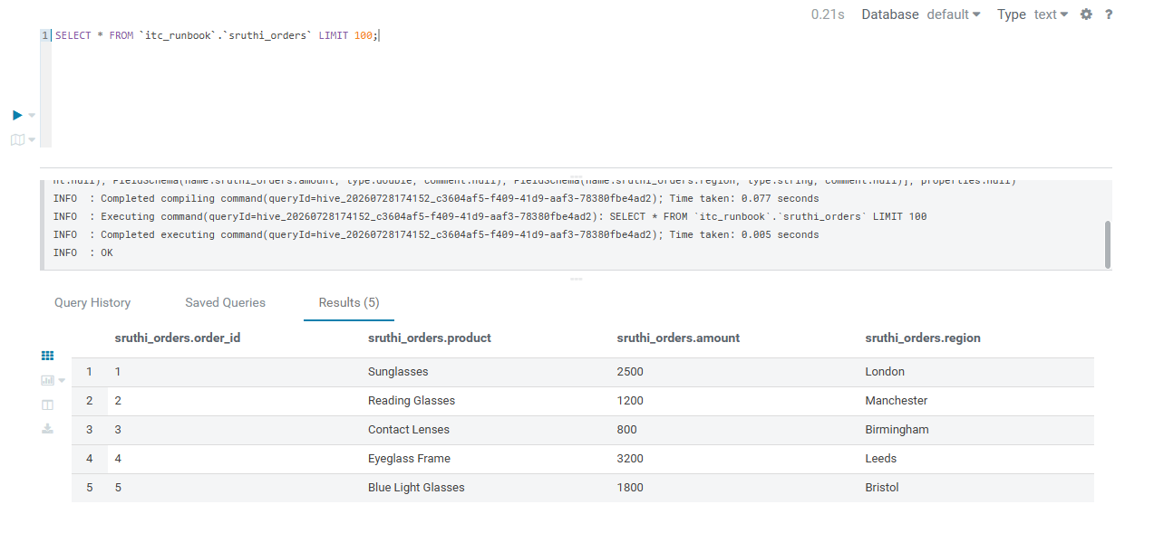
- INVALIDATE METADATA itc_runbook.sruthi_orders;
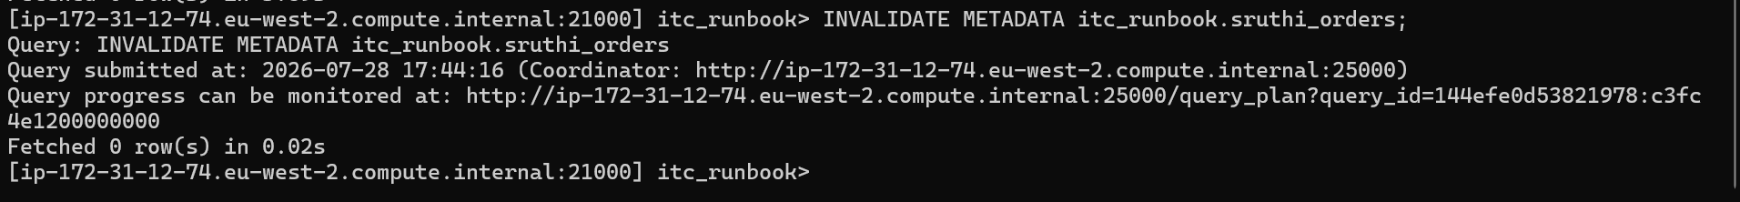
- 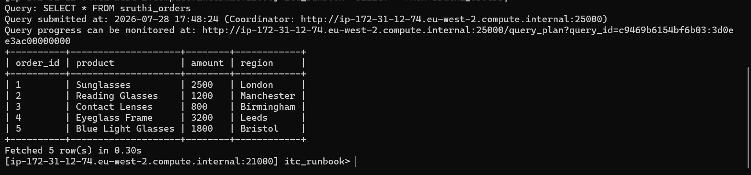
- Query plan
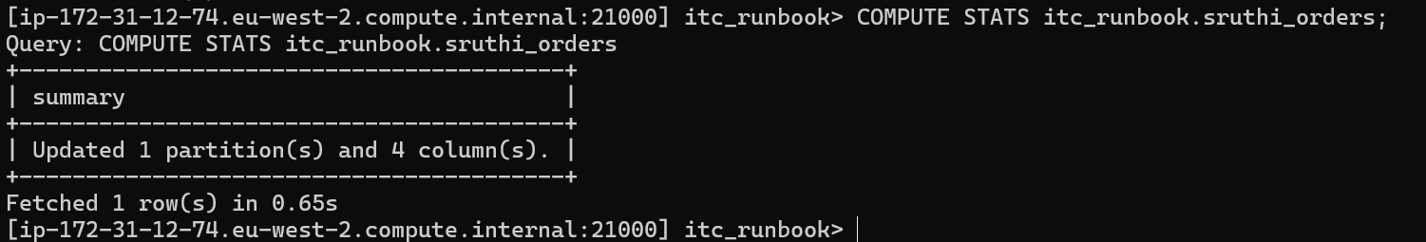
Execution plan
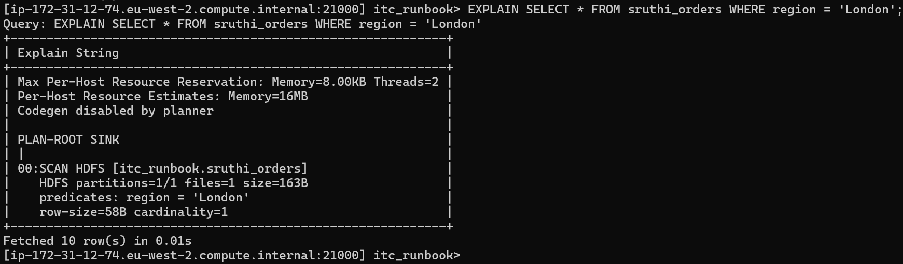

Day 7

- Open a PySpark shell on the cluster
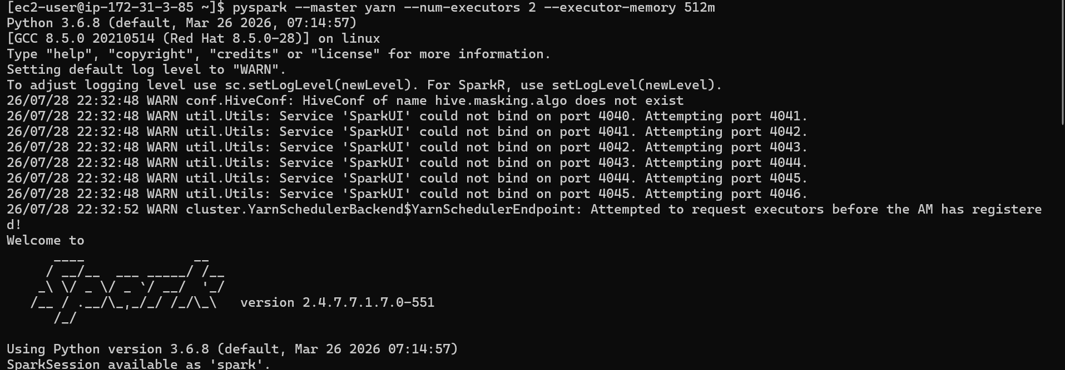
- Read employees.csv from HDFS into a DataFrame
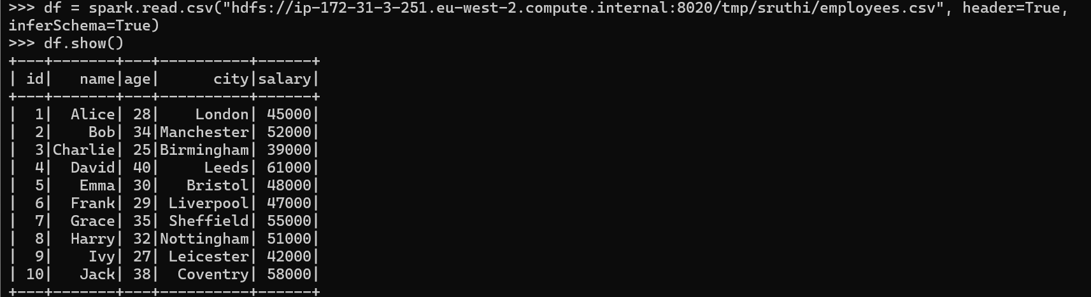

- Add a senior column: True if age >= 35, else False
from pyspark.sql import functions as F

df_senior = df.withColumn("senior", F.col("age") >= 35)
df_senior.show()
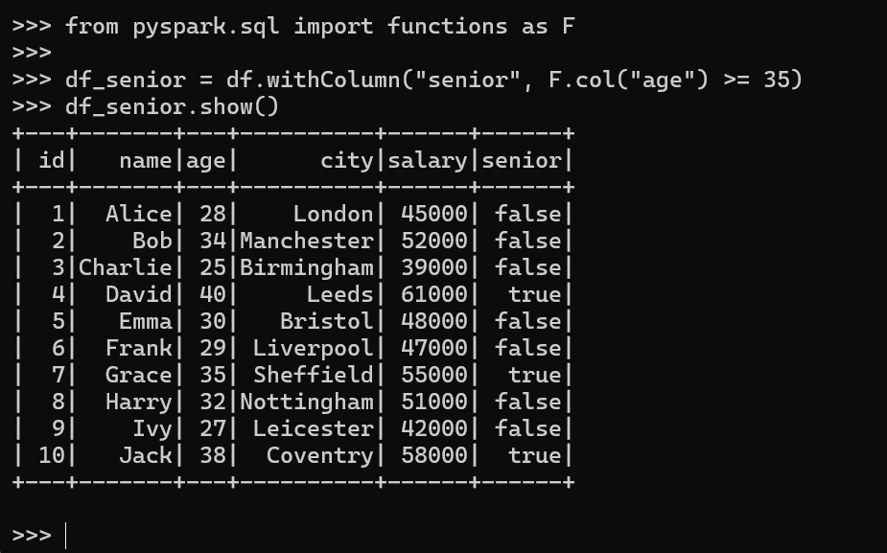
- Calculate average salary for senior vs junior employees
df_senior.groupBy("senior").agg(F.avg("salary").alias("avg_salary")).show()
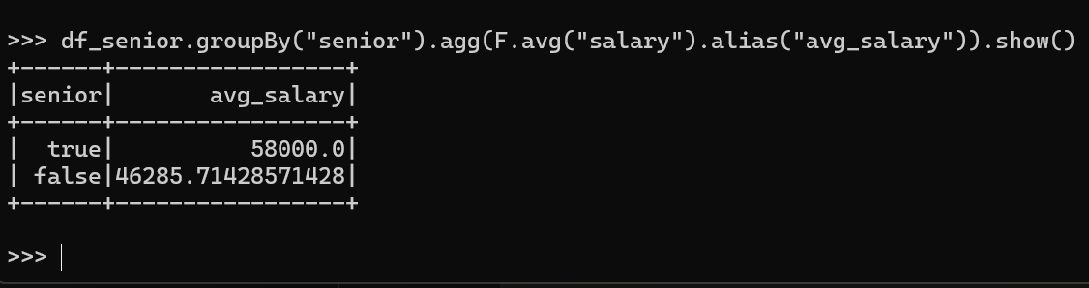
- Write the result as Hive table itc_runbook.<yourname>_analysis
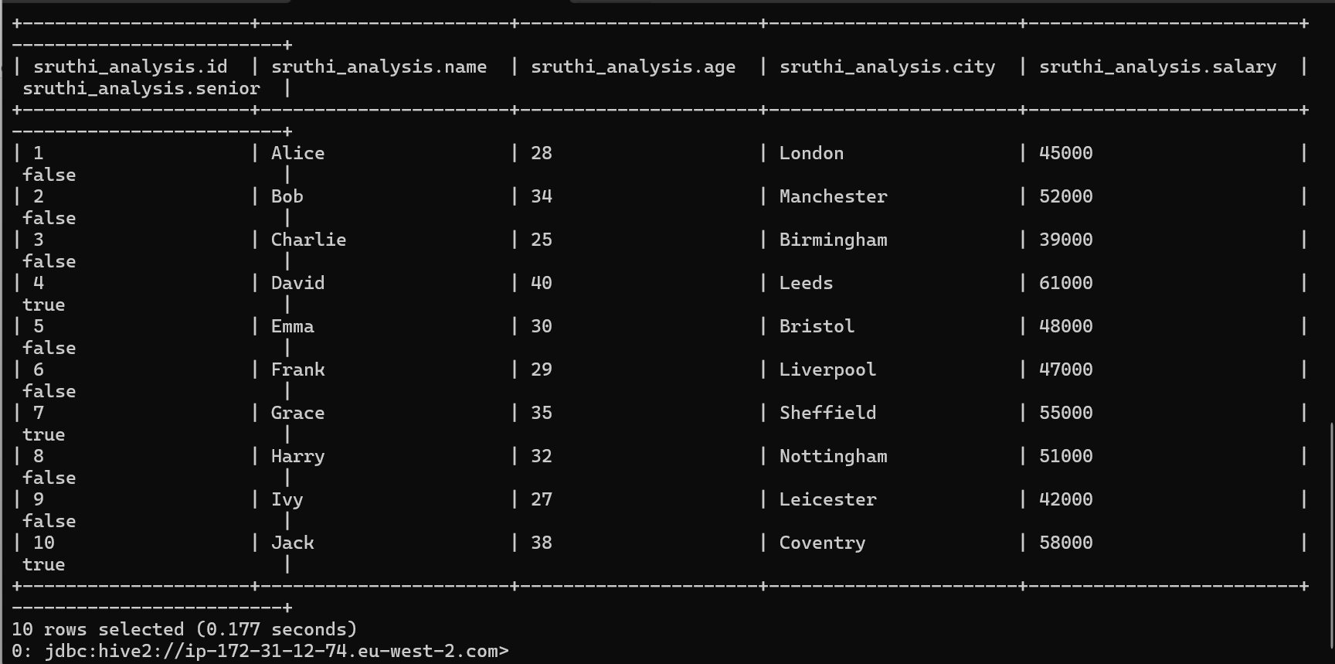

Day 8

- Create a Kafka topic: <yourname>_test with 3 partitions
kafka-topics --create \
--topic sruthi_test \
--bootstrap-server ip-172-31-3-251.eu-west-2.compute.internal:9092 \
--partitions 3 \
--replication-factor 1
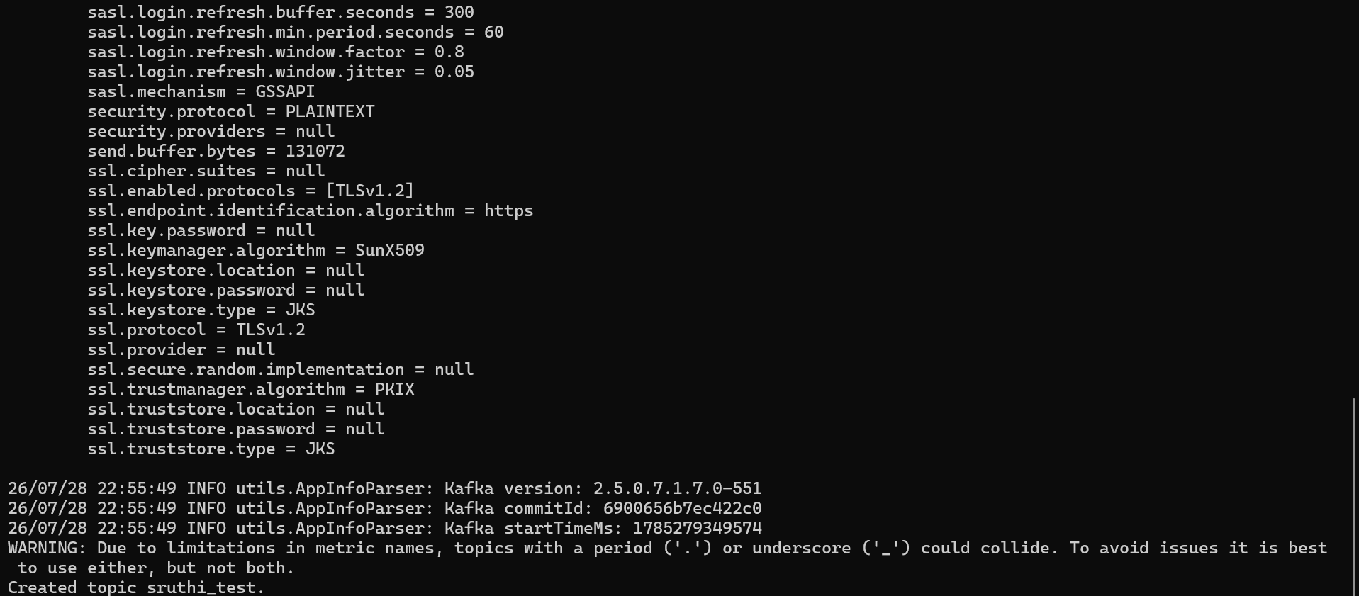

Verify it was created
kafka-topics --describe \
--topic sruthi_test \
--bootstrap-server ip-172-31-3-251.eu-west-2.compute.internal:9092

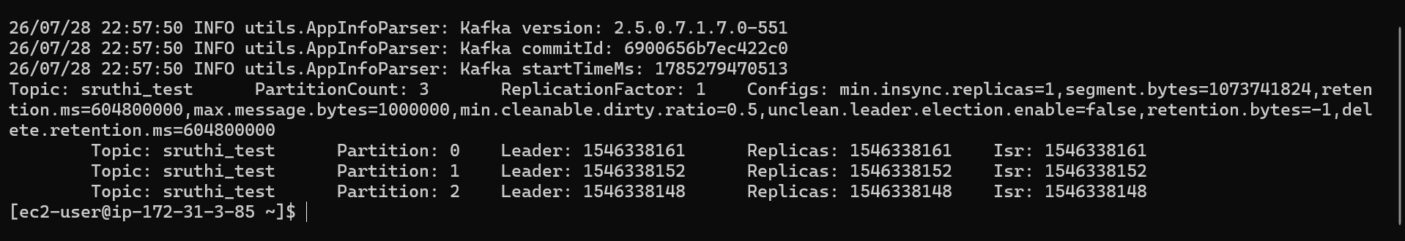
- Write a Python producer that sends 10 employee records as JSON

cat > /tmp/kafka_producer.py << 'PYEOF'
from kafka import KafkaProducer
import json

BROKERS = [
"ip-172-31-3-251.eu-west-2.compute.internal:9092",
"ip-172-31-6-42.eu-west-2.compute.internal:9092",
"ip-172-31-3-85.eu-west-2.compute.internal:9092"
]

producer = KafkaProducer(
bootstrap_servers=BROKERS,
value_serializer=lambda v: json.dumps(v).encode('utf-8')
)

employees = [
{"id": 1, "name": "Alice", "age": 28, "city": "London", "salary": 45000},
{"id": 2, "name": "Bob", "age": 34, "city": "Manchester", "salary": 52000},
{"id": 3, "name": "Charlie", "age": 25, "city": "Birmingham", "salary": 39000},
{"id": 4, "name": "David", "age": 40, "city": "Leeds", "salary": 61000},
{"id": 5, "name": "Emma", "age": 30, "city": "Bristol", "salary": 48000},
{"id": 6, "name": "Frank", "age": 29, "city": "Liverpool", "salary": 47000},
{"id": 7, "name": "Grace", "age": 35, "city": "Sheffield", "salary": 55000},
{"id": 8, "name": "Harry", "age": 32, "city": "Nottingham", "salary": 51000},
{"id": 9, "name": "Ivy", "age": 27, "city": "Leicester", "salary": 42000},
{"id": 10, "name": "Jack", "age": 38, "city": "Coventry", "salary": 58000}
]
for emp in employees:
producer.send("sruthi_test", value=emp)
print(f"Sent: {emp}")

producer.flush()
producer.close()
PYEOF
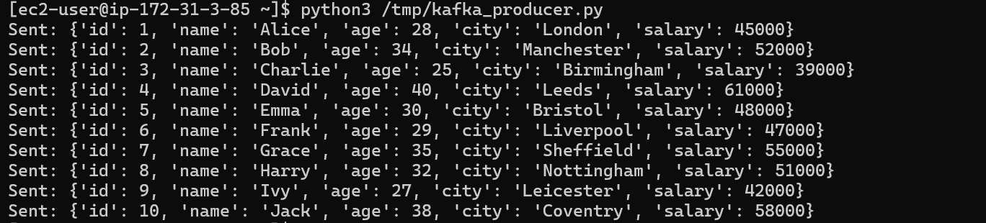
- Write a Python consumer that reads them and prints only salary > 50000
cat > /tmp/kafka_consumer.py << 'PYEOF'
from kafka import KafkaConsumer
import json

consumer = KafkaConsumer(
"sruthi_test",
bootstrap_servers=["ip-172-31-3-251.eu-west-2.compute.internal:9092"],
auto_offset_reset="earliest",
value_deserializer=lambda v: json.loads(v.decode('utf-8')),
group_id="sruthi_group",
consumer_timeout_ms=10000
)

for msg in consumer:
emp = msg.value
if emp["salary"] > 50000:
print(f"{emp['name']} - {emp['city']} - £{emp['salary']}")

print("Done reading.")
PYEOF


- Check consumer lag with kafka-consumer-groups --describe
kafka-consumer-groups \
--bootstrap-server ip-172-31-3-251.eu-west-2.compute.internal:9092 \
--group sruthi_group \ --describe
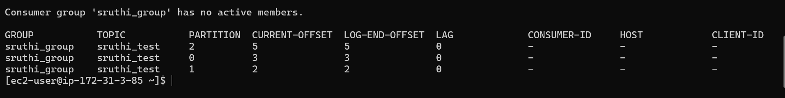
- Delete
kafka-topics --delete \
--topic sruthi_test \
--bootstrap-server ip-172-31-3-251.eu-west-2.compute.internal:9092

